Snagit User Manual

Table of Contents

Description 2

Download Instructions 2

Capturing screenshots 3

Image Editing 4

Description

TechSmith’s Snagit is a screen capture tool that you can use to capture and edit screenshots and create gifs/videos for instructional content.

Download Instructions

1. To download the screen capture tool Snagit, click on the link <https://www.techsmith.com/screen-capture.html>, or copy and paste the link in your browser.
2. For a free trial version, click on the **Free Download** button in the top-right corner of the web page that opens as highlighted in green, in Figure 1.



Figure 1: Snagit webpage

1. Choose the Mac or Windows version based on your need.
2. On a Mac laptop, to begin installing the application, click on the downloaded *Snagit.dmg*  file and drag the application to the ***Applications*** folder as seen in Figure 2.

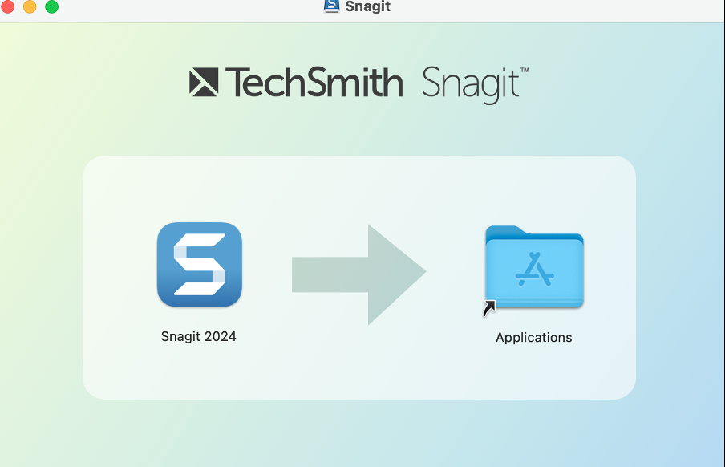

Figure 2: Installation

1. You are all set to begin using Snagit!

Capturing screenshots

This section will guide you in capturing screenshots using Snagit.

1. From the Snagit **File** menu item in the menu bar start a new capture by clicking on the *New Capture* list as shown in Figure 3.  
     
   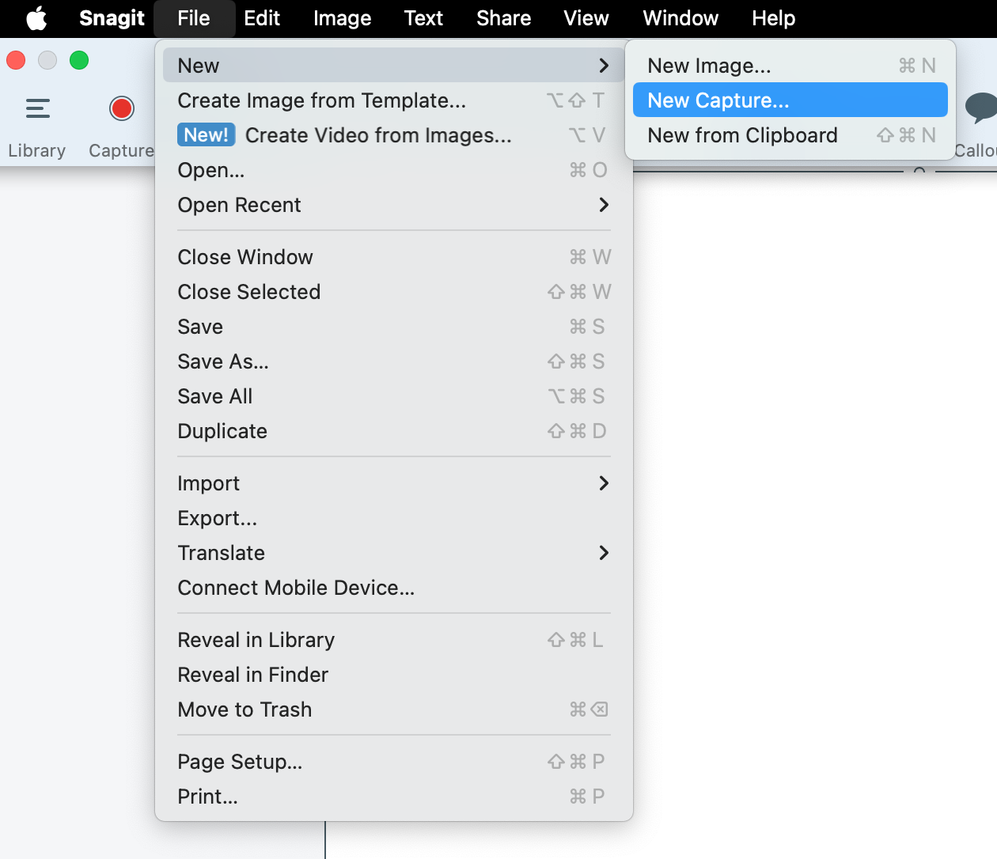

Figure 3: New capture

You can also start a new capture by clicking on the Snagit icon  in the Mac menu bar in the top right corner and then clicking on the **Capture** button.

1. You can set your preferences in the window that appears.  
     
   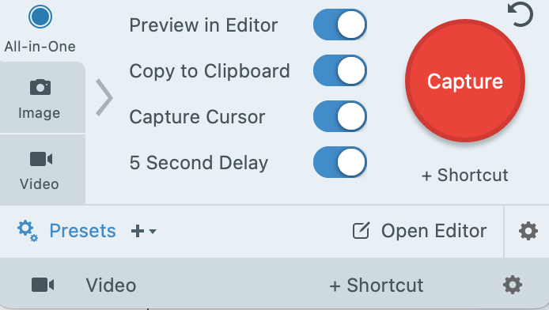
2. Now, with the image that you would like to capture visible on your screen, click the red **Capture** button.
3. This initiates a countdown at the end of which you will see a set of cross hairs at the tip of your cursor. Use these to select the area that you would like to capture in your screenshot.
4. Drag over the selected area and let go.
5. This captures the screenshot that you can then save to your clipboard or paste it where you require it.
6. You can also edit this image in Snagit to add a border, callouts, text and other image edits. For more details, refer to Image editing.

Image Editing